PRATICAL
EXPRIMENT -1
1.Creation of a Simple Cloud-Based Hospital Management System Using Zoho Creator to Demonstrate Software as a Service (SaaS)
AIM:
To develop a simple cloud-based Hospital Management System using Zoho Creator and demonstrate the Software as a Service (SaaS) model of cloud computing by providing the application over the internet.
PROCEDURE:
- Opened Zoho Creator and logged in using a valid Zoho account.
- Created a new cloud application named Hospital Management System.
- Designed forms to store hospital information, including Patient Details, Doctor Details, and Appointment Details.
- Added the required fields such as Patient ID, Patient Name, Age, Gender, Doctor Name, Department, Appointment Date, and Contact Number.
- Configured reports to view, edit, and manage the entered records efficiently.
- Saved and published the application on the Zoho cloud platform.
- Accessed the application through a web browser to verify that it works without installing any software on the local computer.
- Captured screenshots of the application to demonstrate the successful implementation of the Software as a Service (SaaS) model, where the application is hosted on the cloud and can be accessed anytime through the internet.
  - Patient details
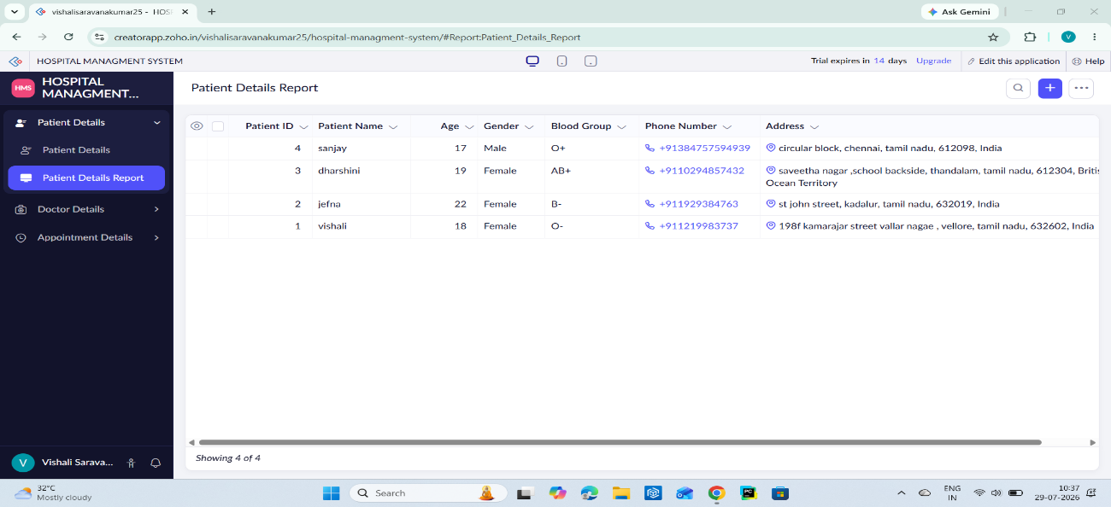
  - Doctor details
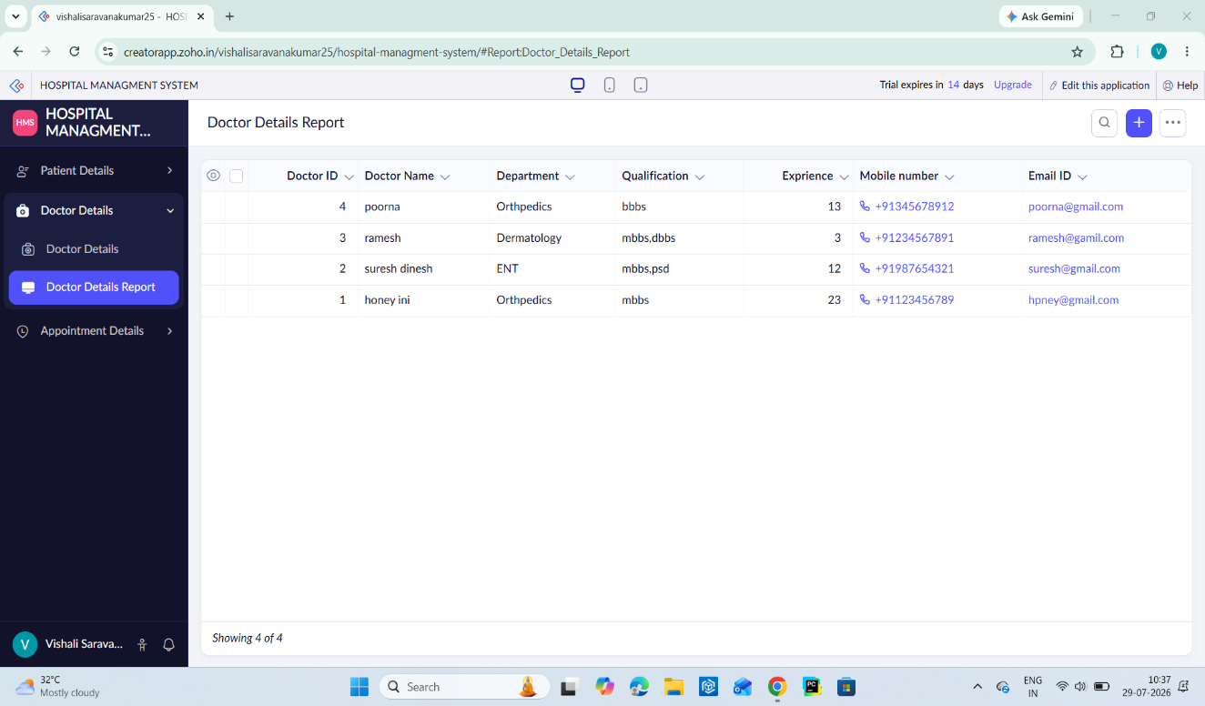
  - Appointment Details
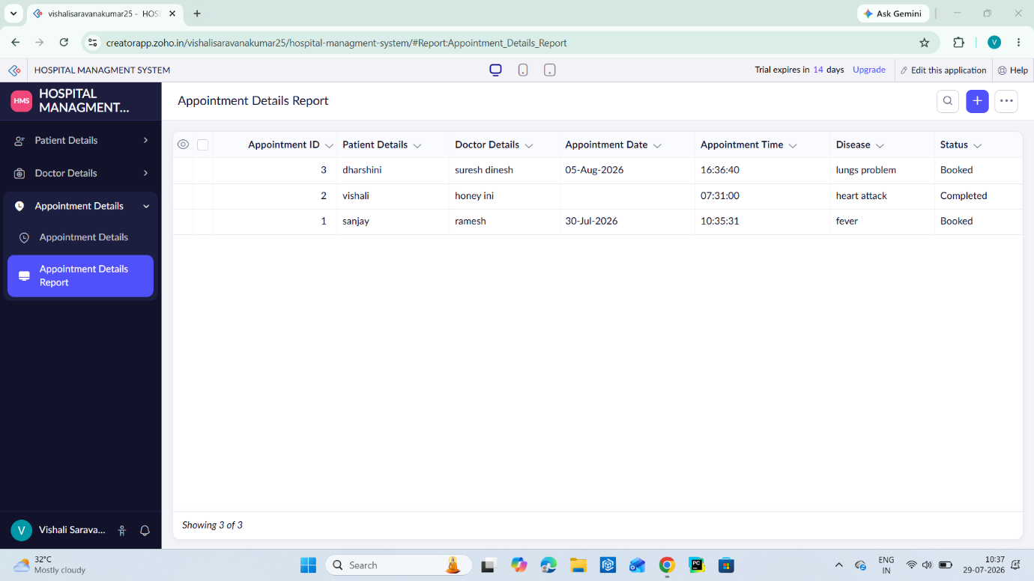
Result:
The Hospital Management System was successfully developed and deployed using Zoho Creator. The application allows users to manage patient, doctor, and appointment details through a web browser. This experiment successfully demonstrates the Software as a Service (SaaS) model, where the software is hosted on the cloud and can be accessed anytime and anywhere over the internet without installing or maintaining it on a local computer.

